Team Handball Handout
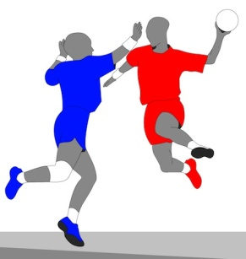
History:
Team handball originated in Europe in the 1900’s. Handball first appeared in the 1936 Olympic Games in Berlin as an outdoor sport with 11 players per side. It was not played again at the Olympics until 1972, where it was played indoors with 7 players on each team.
Object of the game:
- Handball combines the elements of soccer, basketball & water polo
- 6 players move the ball around on a court that is larger than a basketball court and try to score by throwing the ball past the goalkeeper into the net; 6 players on the court & 1 goalie = 7 players per side
- Players are allowed to throw from outside the goal area; only the goal keeper can be in the arc
Rule of 3’s:
- Players are allowed to take 3 steps
- Players are allowed to hold the ball for 3 seconds
- Players are allowed to take 3 dribbles
Players are not allowed to:
- Endanger an opponent with the ball
- Pull, hit or punch the ball out of the hands of an opponent
- Go in the goalie areal; only the goalie is allowed to stay in the arc
Defense:
- Players must stay an arm’s length away from the other team
3 types of shots:
- Jump shot - player jumps in the air and releases the ball before landing on the ground
- Fall shot - as player is falling to the ground they throw the ball at the net
- Bounce shot – when the ball bounces before going into the goal
*All three shots are done with players shooting behind the arc**

